Child Information Sheet

Title of the study

Note: all pictures/graphics are examples only to provide options/ideas

Similarly the font is chosen as “Child-friendly” similar fonts are also acceptable

This information sheet has been put together to help you decide if you would like to take part in our research project.

**Why are we asking you?**

We are asking you to take part in this project because:

* [Include minimal inclusion criteria that child will understand]

**Why are we doing this project?**

Brief description of study and picture of any devices or procedures for example the following was for a diabetes project:

People with Type 1 Diabetes are using insulin pumps more and more to manage their blood glucose levels. This project is looking at how new insulin pumps can be used to shorten the time you have low blood glucose levels.

We are testing the new Medtronic MiniMed 640G insulin pump (picture 1). When the pump is used with a glucose sensor (picture 2), it can pause insulin when it thinks you are going to go low. The pump has a special mathematical equation so that the pump knows when to pause the insulin. It has another mathematical equation to restart the insulin to avoid you going high after the pause.

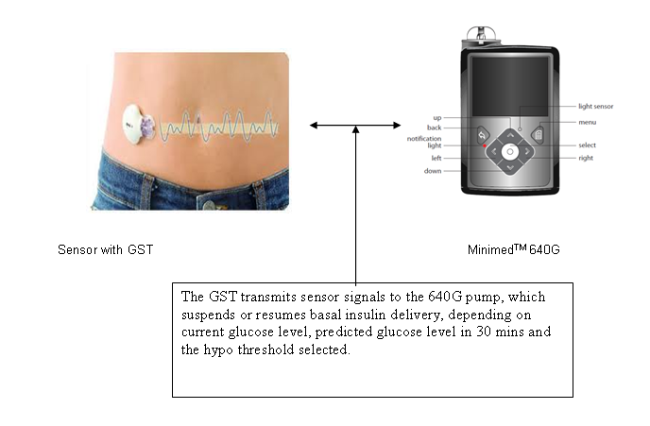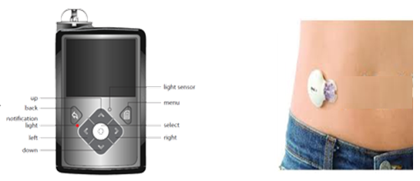

a

ba

This study will look at whether having the equation reduces the amount of time you have low blood glucose levels and what you think about the pump.

(See examples of possible pictures of different medical procedures at the end of the document)

**How the Project works…**

Include a brief description about what happens during the study including (dot point forms are preferred):

* How many times they need to attend the clinics
* Whether they have to do anything at home or school
* What will be done to the participant
* What The participant has to do
* What the parents will have to do

[](http://www.google.com.au/url?sa=i&rct=j&q=&esrc=s&frm=1&source=images&cd=&cad=rja&docid=ud1cvtHVmoSvMM&tbnid=_5ztoY4rDLCRpM:&ved=0CAUQjRw&url=http://vasblog.com/&ei=IcHdUoTFCoavkgXJt4AI&psig=AFQjCNHdYTqGq9HsP4I7x-zbIMR7nL70LQ&ust=13903508551929)

**Do I have to take part?**

No you don’t. If you say no, that is ok. It is up to you.

If you say yes, and then change your mind later on, that is okay as well. All you need to do is tell the researcher that you don’t want to take part anymore. You also don’t need to answer any question that you don’t want to as well, that is okay too.

**Good and bad parts of the project**

Some bad things that could happen in the project are:

List some possible occurrences that are likely to affect the participant eg pain from procedures, being tried etc Explain they should tell their parents/caregiver and the researchers and they will be able to help them

Some good things that can happen in the project:

List some possible benefits without offering inducements

**What happens to the information I tell you?**

Information about you that is collected for the project will be put away and no-one but the researcher will be able to see it. If we tell people about the results of the project we will not use your name. The information could be used with information from other young people in reports or papers about the research. The results are written so that no one will know who was in the project.

 

The only time the researchers would have to tell someone, is if anyone hurt you or upset you in any way. The researchers would also have to tell someone if you said you might hurt yourself or someone else.

All information about you is kept safe in a secure office and on a special computer with a password. After 25 years, all the information will be destroyed.

**Anything else?**

You need to understand why we are doing this project, and what we will be asking you to do in this project. Talk about the project with your parents and ask questions about the project before making a decision.

If you would like to know more about this project, or would like to take part, you or your mum, dad, or usual caregiver can call a member of the research team on ________________.

It anything happens whilst you are in this research tell your mum, dad or caregiver and they will know who to talk to.

**Thank you for reading this letter.**