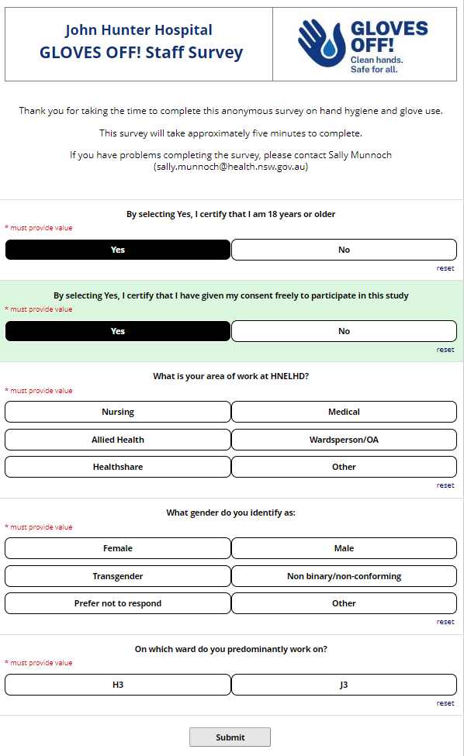

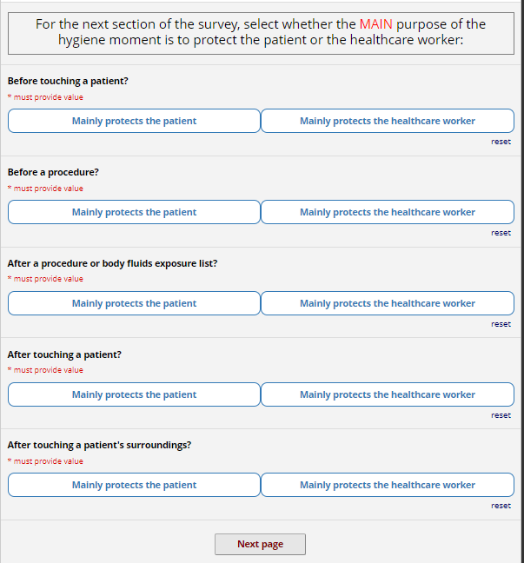

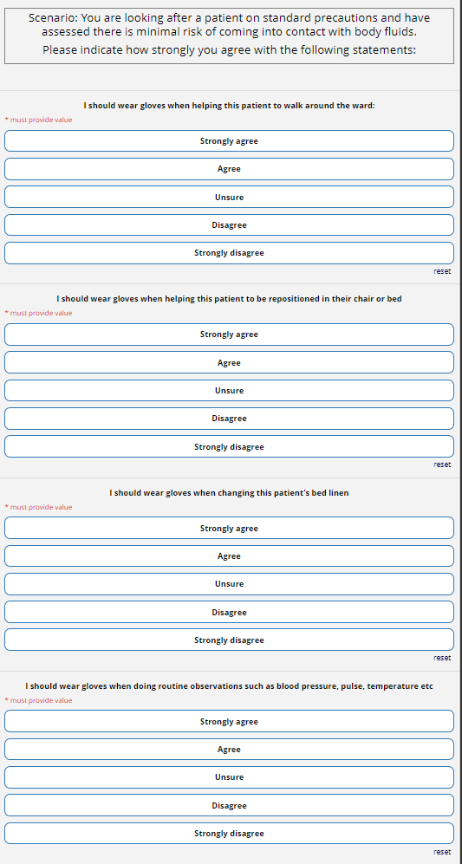
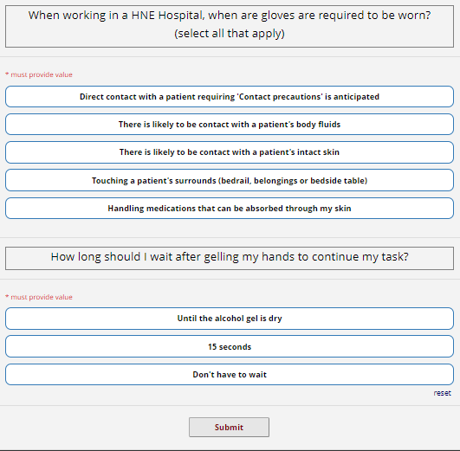

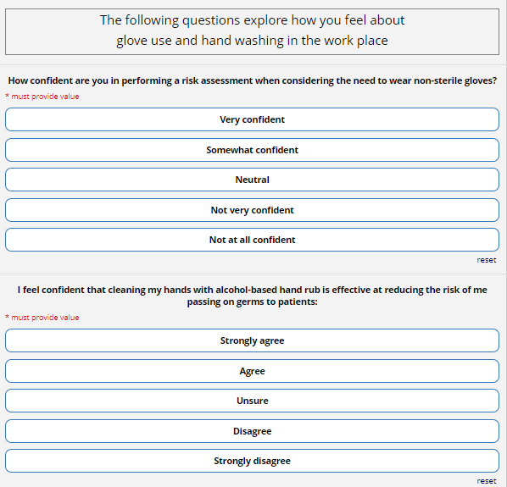
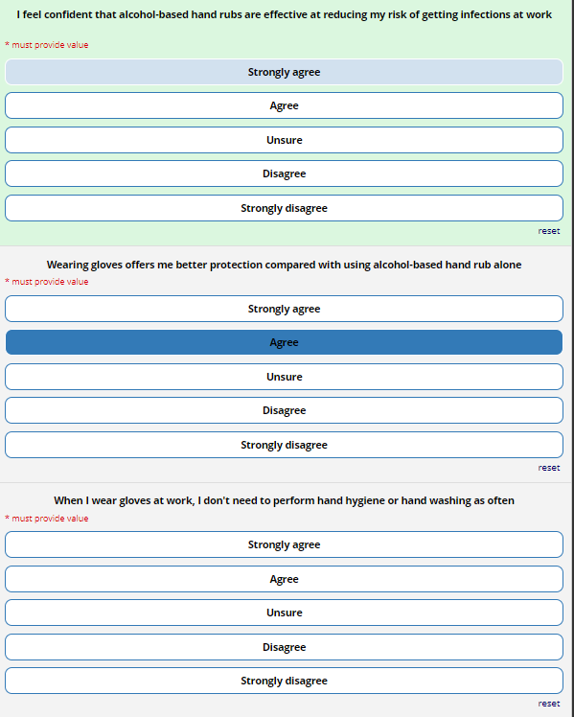
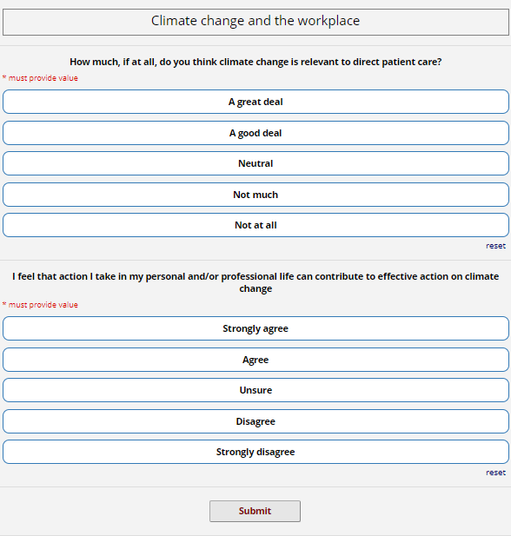
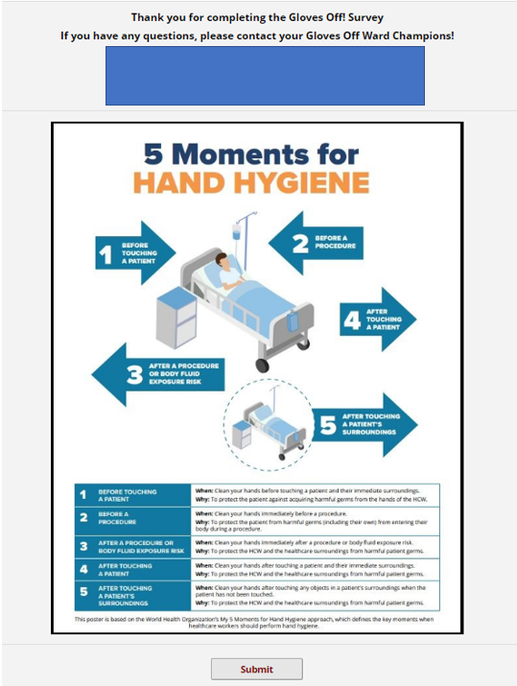
Study data were collected and managed using REDCap electronic data capture tools hosted at Hunter New England Local Health District.^{1,2} REDCap (Research Electronic Data Capture) is a secure, web-based software platform designed to support data capture for research studies, providing 1) an intuitive interface for validated data capture; 2) audit trails for tracking data manipulation and export procedures; 3) automated export procedures for seamless data downloads to common statistical packages; and 4) procedures for data integration and interoperability with external sources.

¹PA Harris, R Taylor, R Thielke, J Payne, N Gonzalez, JG. Conde, Research electronic data capture (REDCap) – A metadata-driven methodology and workflow process for providing translational research informatics support, J Biomed Inform. 2009 Apr;42(2):377-81.
²PA Harris, R Taylor, BL Minor, V Elliott, M Fernandez, L O’Neal, L McLeod, G Delacqua, F Delacqua, J Kirby, SN Duda, REDCap Consortium, The REDCap consortium: Building an international community of software partners, J Biomed Inform. 2019 May 9 [doi: 10.1016/j.jbi.2019.103208]

